"Bharat Museum Tickets"
A CHATBOT BASED TICKETING SYSTEM
A project report submitted in partial fulfilment of the
requirements for the award of the degree of
BACHELOR OF TECHNOLOGY
(Department of Information Technology)
&
(Department of Computer Science and Engineering)
(BATCH 2021-2025)
Submitted by
Name | Roll No. | Registration No.
Soumita Gupta | 24400122085 | 222440110074 OF 2022-23
Sulagna Ghosh | 24400122042 | 222440110089 OF 2022-23
Souvik Gon | 24400122050 | 222440110080 OF 2022-23
Dipon Biswas | 24400122062 | 222440110025 OF 2022-23
Debanjan Paul | 24400122009 | 222440110021 OF 2022-23
Under the esteemed guidance of -
Mr. Sujit Raha


Submitted To
Techno Engineering College Banipur
is affiliated to
Maulana Abul Kalam Azad University of Technology
(Formerly known as West Bengal University of Technology)
TO WHOM IT MAY CONCERN

This is to certify that the project entitled "Bharat Museum Tickets – A Chatbot Based Ticketing System" is being submitted by "Soumita Gupta" (Roll No.: 24400122085), "Sulagna Ghosh" (Roll No.: 24400122042), "Souvik Gon" (Roll No.: 24400122050), "Dipon Biswas" (Roll No.: 24400122062), and "Debanjan Paul" (Roll No.: 24400122009) in partial fulfilment of the requirement for the award of the degree of "Bachelor of Technology" in the Departments of Computer Science and Engineering from Techno Engineering College Banipur (affiliated to Maulana Abul Kalam Azad University Of Technology).

____________________________  Signature of the Project Guide  Mr. Sujit Raha (CSE)  Asst. Professor, Dept of CSE | ________________________  Signature of the  Head of the Dept.  Dr. Hari Narayan Khan | _________________________  Signature of Principal Sir  Dr. Maloy Kumar Chandra  Techno Engineering College Banipur

CERTIFICATE OF APPROVAL

This is to certify that the thesis entitled "Bharat Museum Tickets – A Chatbot Based Ticketing System" is a bona fide record of work carried out by "Soumita Gupta", "Sulagna Ghosh", "Souvik Gon", "Dipon Biswas", and "Debanjan Paul" in partial fulfilment of the requirements for the award of the degree of "Bachelor of Technology" in the Departments of Computer Science and Engineering, Techno Engineering College Banipur, during the period 2022-2026. It is understood that by this approval the undersigned do not necessarily endorse or approve any statement made, opinion expressed, or conclusion drawn herein, but approve the thesis only for the purpose for which it has been submitted.

__________________________ | ___________________________
Signature of the Examiner(s) | Signature of the Supervisor(s)

Acknowledgement

The development of this project, as well as the preparation of this report, has been a meaningful learning experience enriched with continuous guidance, encouragement, and support from many individuals. Throughout the journey of developing "Bharat Museum Tickets – A Chatbot Based Ticketing System," we have received invaluable assistance and motivation from those who contributed to the successful completion of this project.
We would like to express our sincere gratitude to our project supervisor, Mr. Sujit Raha, Assistant Professor, Department of Computer Science & Engineering, for his constant guidance, encouragement, and valuable suggestions throughout the development of this project. His support and technical expertise greatly contributed to the successful completion of this project. His motivation, insightful feedback, and unwavering support inspired us to overcome challenges and complete every phase of the project with confidence and dedication.
We are also thankful to Dr. Hari Narayan Khan, Head of the Department, for his continuous encouragement, academic guidance, and valuable suggestions throughout our project work. We extend our sincere appreciation to all the faculty members of the Department of Computer Science & Engineering, Techno Engineering College Banipur, for their constant support, motivation, and guidance during our academic journey.
We would also like to thank the laboratory staff for their assistance and for ensuring that the necessary laboratory resources and facilities were available whenever required throughout the development of this project.
Last but not least, we express our heartfelt gratitude to our classmates and batchmates of B.Tech CSE (Batch: 2022–2026) for their cooperation, encouragement, and moral support throughout this project. Finally, we express our deepest gratitude to our parents and family members for their unconditional support, patience, and motivation, without which this work would not have been possible.

____________________ | _____________________ | ___________________ |  | ______________________ |  | _____________________
Soumita Gupta  CSE  (24400122085) | Sulagna Ghosh  CSE  (24400122042) | Souvik Gon  CSE  (24400122050) | Dipon Biswas  CSE  (24400122062) |  | Debanjan Paul  CSE  (24400122009)

DECLARATION OF ORIGINALITY AND COMPLIANCE WITH ACADEMIC ETHICS

We, the undersigned candidates, hereby declare that this thesis contains a comprehensive literature survey and original research work carried out by us. The project report entitled "Bharat Museum Tickets – A Chatbot Based Ticketing System" is submitted in partial fulfilment of the requirements for the award of the degree of Bachelor of Technology in Computer Science & Engineering.
We further declare that the work presented in this report is original and has been completed under the guidance of our project supervisor. This project has not been submitted, either wholly or
partially, for the award of any other degree or diploma at this or any other institution.
We hereby certify that all information, data, and materials included in this report have been obtained and presented in accordance with accepted academic rules and ethical practices. All sources of information, published literature, and reference materials used during this work have been properly acknowledged and cited. We further declare that all content, ideas, and results that are not original to this work have been appropriately referenced.
We understand that any violation of academic integrity, including plagiarism or misrepresentation of work, may lead to disciplinary action as per the rules of the Institute and the University.

____________________ | _____________________ | ___________________ |  | ______________________ |  | _____________________
Soumita Gupta  CSE  (24400122085) | Sulagna Ghosh  CSE  (24400122042) | Souvik Gon  CSE  (24400122050) | Dipon Biswas  CSE  (24400122062) |  | Debanjan Paul  CSE  (24400122009)

Index
Index 6
Title Of The Project 8
Abstract 9
1. Introduction 10
2. Literature Survey: 11
3. Key Features: 12
4. Motivation: 14
🔹 Multilingual Support 14
🔹 Omnichannel Access (Web, Mobile, Chat) 14
🔹 Automated Ticketing & Payment Processing 14
🔹 Personalized Visitor Experience 14
🔹 Real-Time Assistance 14
🔹 Crowd Management Insights 15
🔹 Data Analytics for Operational Improvements 15
🔹 Need for 24/7 Automated Booking 15
🔹 Scalability & High-Volume Handling 15
🔹 Accessibility for Specially-Abled Visitors 15
🔹 Reducing Human Error & Increasing Automation 15
🔹 Environmental Motivation (Paperless System) 16
🔹 Enhanced Visitor Experience & Engagement 16
5. Objectives: 17
6. Technology Required: 19
A. Chatbot Engine: ChatterBot (Python) 19
B. NLP Framework: spaCy 20
C. Backend Technology: Next.js Server & Node.js Runtime 20
D. Database Layer 21
a. Firestore Database (FSDB) 21
b. Firebase 22
E. Cloud Hosting 24
a. Vercel 24
b. Render 24
F. Frontend: Next.JS 24
G. Additional Technical Elements 25
a. API Integration 25
b. Payment Gateway 25
c. Real-Time Database Updates 25
d. Authentication Services 25
H. IoT & Hardware Integration 26
a. ESP32 DevKit V1 (Main Controller) 26
b. HC-SR04 Ultrasonic Sensor 26
c. IR Sensor 27
d. RFID RC522 Module 27
e. Servo Motor SG90 27
7. Methodology: 29
A. System Overview: 29
B. Frontend Layer (Next Js): 29
C. Backend Layer (Next.js Server and API Routes) 29
D. AI & NLP Layer (Python): 30
E. Chatbot Engine: ChatterBot and NLP Framework: spaCy: 30
F. Database Layer: 30
G. Payment Gateway Integration: 31
H. Cloud Hosting Layer: 31
I. IoT & Hardware Layer: 32
a. Complete system architecture 32
b. Entry gate architecture 33
c. Exit gate architecture 34
d. Anti-tailgating security logic 35
e. OLED display workflow 36
f. Manual gate control (dashboard controls) 37
g. Visitor transaction flow 38
h.Firestore collections 39
i.System State Machine 41
j. ESP32 Microcontroller and HC-SR04 Ultrasonic Sensor: 42
k. IR Proximity Sensor and RFID RC522 Module: 42
8. DFD ( Data Flow Diagram ) 43
9. Sequence Diagram 44
10. ER ( Entity Relationship ) Diagram 45
11. Analysis 46
12. Conclusion: 47
13. Future Work: 48
14. References 49

Title Of The Project
“Bharat Museum Tickets”
A Chatbot Based Ticketing System For Museums

Abstract
Recent advances in digital technologies have significantly transformed visitor management practices in museums, shifting from traditional paper-based ticketing systems to digital, QR-code-based e-ticketing and mobile booking platforms. Alongside this transition, conversational AI systems such as chatbots are increasingly adopted to enhance visitor engagement, provide real-time assistance, and automate service delivery. This project presents an integrated AI-based smart museum management system that combines chatbot-driven interaction, natural language processing, cloud-based backend services, real-time databases, and IoT hardware for automated ticketing, access control, and visitor analytics. The system leverages NLP frameworks to enable multilingual, natural, and context-aware conversations, allowing users to book tickets, receive personalized recommendations, and access museum information seamlessly across multiple channels. Cloud infrastructure ensures scalability, security, and real-time data synchronization, while IoT components such as RFID, sensors, and microcontrollers enable automated entry validation and crowd monitoring. By integrating predictive analytics and operational data analysis, the system supports informed decision-making and resource optimization for museum administrators. The proposed solution improves accessibility, reduces operational workload, enhances visitor experience, and establishes a scalable foundation for future smart museum applications.

1. Introduction
The rise of digital transformation in Travel & Tourism has created a strong demand for automated, intelligent, and scalable systems to enhance visitor experience and streamline ticketing processes. Traditional ticket counters often suffer from long queues, human errors, limited working hours, and accessibility challenges, particularly for visually impaired users or non-tech-savvy visitors.
Museums play a vital role in preserving cultural heritage, educating the public, and promoting art, history, and science. As museums attract increasingly diverse audiences, the need for efficient, user-friendly, and technologically advanced visitor management systems has become essential. Traditional museum ticketing methods—based on manual counters, printed tickets, and in-person inquiries—are time-consuming, prone to errors, and limited in handling large visitor volumes. To overcome these challenges, an online museum ticketing system integrated with an intelligent chatbot offers a modern, scalable, and visitor-centric solution.
An online museum ticketing system allows visitors to book, pay for, and receive tickets digitally through websites or mobile applications. This eliminates long queues and enables museums to manage visitor flow more effectively. By providing 24/7 online services, visitors can plan their visits, select preferred time slots, and choose exhibitions or guided tours. Digital ticketing also supports secure online payments, automated confirmations, and easy cancellations or rescheduling, improving operational efficiency.
The integration of a chatbot-based ticketing system further enhances the visitor experience by providing an intelligent conversational interface. The chatbot guides users through ticket booking and answers queries related to ticket prices, opening hours, exhibitions, discounts, accessibility facilities, and special events. It also assists visitors in selecting ticket types, confirming booking details, and completing payments seamlessly.
A major advantage of the chatbot-integrated system is real-time assistance without human intervention. It efficiently handles repetitive inquiries, reduces staff workload, ensures consistent information delivery, and remains available 24/7, significantly improving user satisfaction and engagement.
From an administrative perspective, the system provides valuable insights through data analytics by collecting information on visitor behaviour, popular exhibitions, peak hours, and ticket demand. These insights help optimize pricing, exhibition planning, crowd management, and resource allocation. The centralized digital platform also simplifies record-keeping, reporting, and integration with entry control, visitor tracking, and feedback systems.
Security and transparency are additional strengths of the proposed system. Digital transactions reduce ticket fraud, cash mismanagement, and unauthorized access. QR-code-based e-tickets enable faster entry validation, while the chatbot provides booking confirmations, reminders, policy updates, and emergency notifications, ensuring timely and reliable communication.

2. Literature Survey:
- Contemporary research and practice show a clear shift from paper-based sales to digital, QR-based e-ticketing and mobile booking engines. Several studies and projects demonstrate QR-code tickets, time-slot reservations, and mobile-first booking flows as standard features that reduce queues and simplify entry validation. Recent work also couples ticketing with predictive analytics to forecast visitor load and optimize staffing.
- Parallel to ticketing modernization, museums increasingly experiment with chatbots as conversational front-ends for visitor services. Reviews and systematic studies classify museum chatbots by function (informational, navigational, educational) and note strong potential for 24/7 query handling, multilingual support, and conversational booking flows that guide users through ticket selection and payment. However, systematic reviews identify a persistent gap: many museum chatbots are built and deployed without rigorous user-experience evaluation, leaving open questions about effectiveness and visitor satisfaction.
- Several recent prototypes explicitly merge chatbot interfaces with ticketing backends. Case studies and conference papers describe end-to-end systems that accept natural-language ticket requests, present available time slots, apply discounts, and generate e-tickets with embedded QR codes—often accompanied by admin dashboards for analytics and POS integration. These implementations show feasibility, especially for small-to-medium museums seeking low-cost digital transformation.
- Benefits documented across the literature include reduced staffing pressure on front desks, improved accessibility for remote or out-of-hours users, personalized recommendations (e.g., guided tours matching interests), and richer operational data (visitor counts, peak times). E-ticketing paired with chatbot notifications also improves communication (confirmations, reminders, policy updates) and lowers fraud risk via digital verification.
- Challenges and open problems are well documented: chatbots must handle ambiguous or compound queries, maintain multilingual and accessibility-friendly interactions, and integrate securely with payment systems and existing museum databases. Evaluation challenges persist—many studies report limited usability testing, and emergent large language models (LLMs) introduce new questions about factual accuracy, hallucination risk, and moderation. Future work advised by the literature focuses on rigorous UX studies, hybrid human–AI handoffs for complex queries, privacy-preserving analytics, and LLM-grounding techniques to ensure reliable, exhibit-accurate responses.

3. Key Features:

- Multilingual support enables visitors from different linguistic backgrounds to interact with the system comfortably, allowing the chatbot to understand and respond in multiple languages for better accessibility and inclusivity.

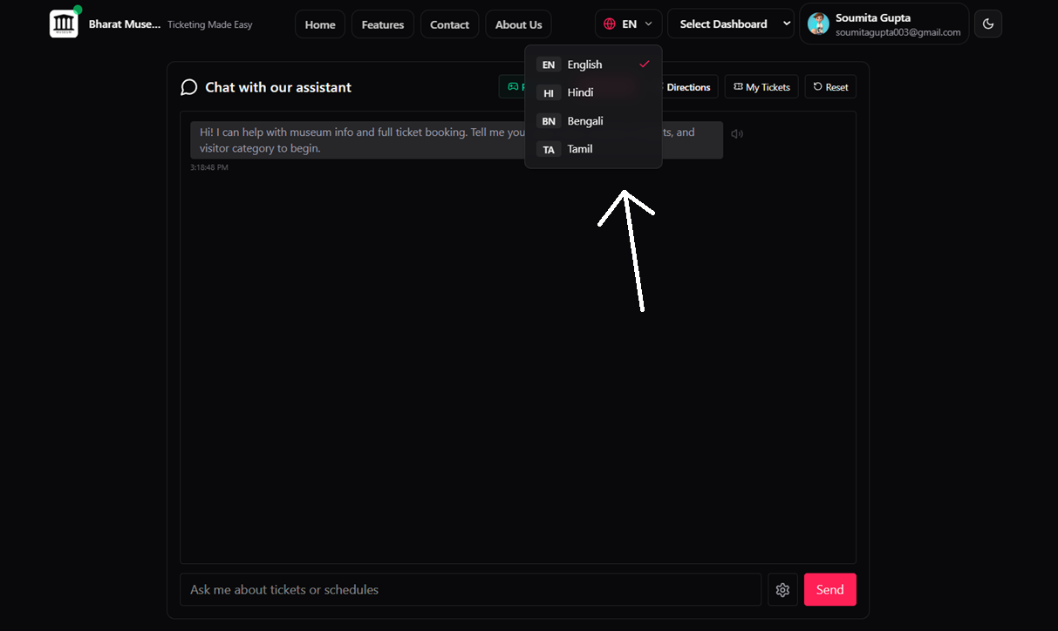

- Omnichannel access allows users to interact with museum services through web platforms, mobile devices, and chat-based interfaces, ensuring seamless availability across different communication channels.

- Automated ticketing and payment processing simplify the booking process by allowing users to check availability, book tickets, and complete secure online payments without manual intervention, reducing queues and errors.

- Personalized visitor experience is provided by analyzing user profiles, preferences, and past interactions to offer customized recommendations, exhibition highlights, and visit suggestions.
- Real-time assistance is delivered through the AI-powered chatbot and backend services, ensuring instant responses to visitor queries related to tickets, exhibits, navigation, and schedules.

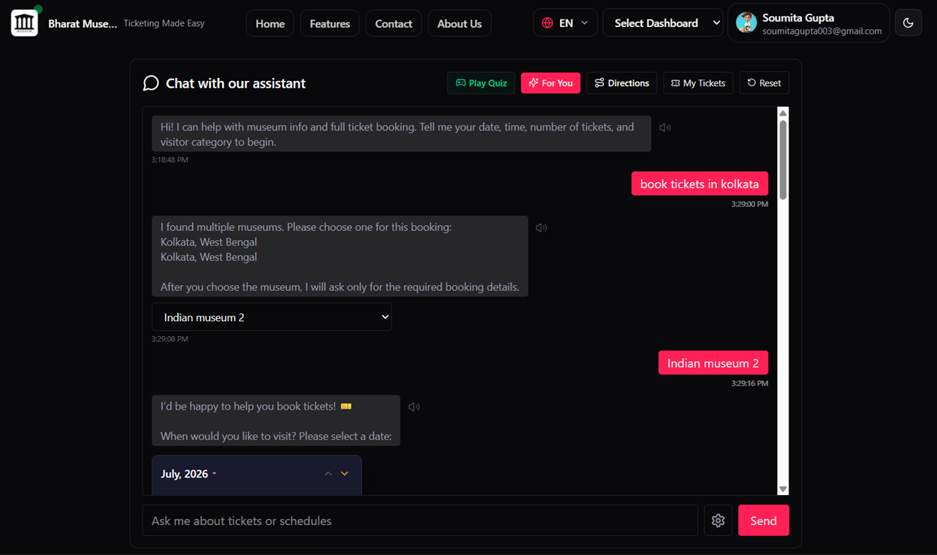
- Crowd management insights are generated using IoT sensors and real-time data processing to monitor visitor flow, identify congestion areas, and support safety and resource optimization.
- Data analytics for operational improvements collects and analyzes data from chatbot interactions, bookings, payments, and sensors to help administrators make informed, data-driven decisions.

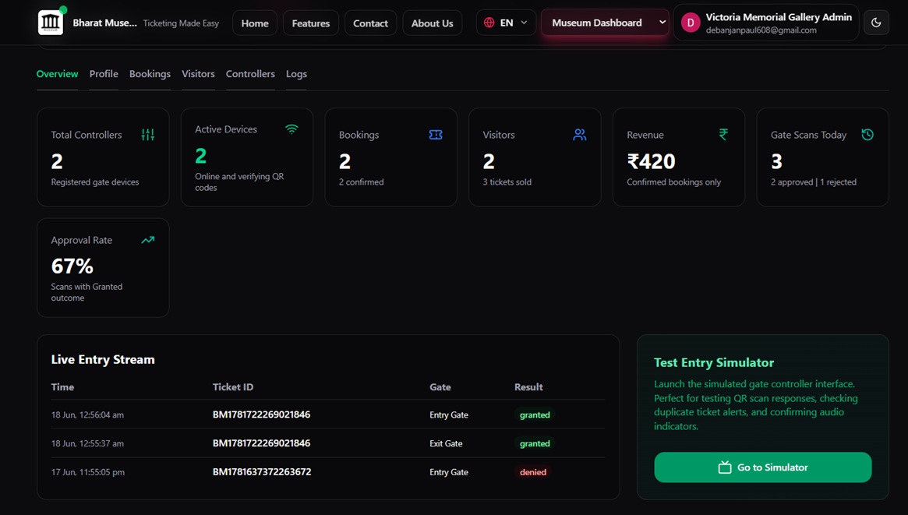
- Virtual guide and video museum tour features allow users to explore exhibits digitally, enhancing engagement and enabling remote access to museum content.

- Accessibility features for visually impaired users, such as voice guidance and screen-reader-friendly interfaces, ensure inclusive access to museum services.

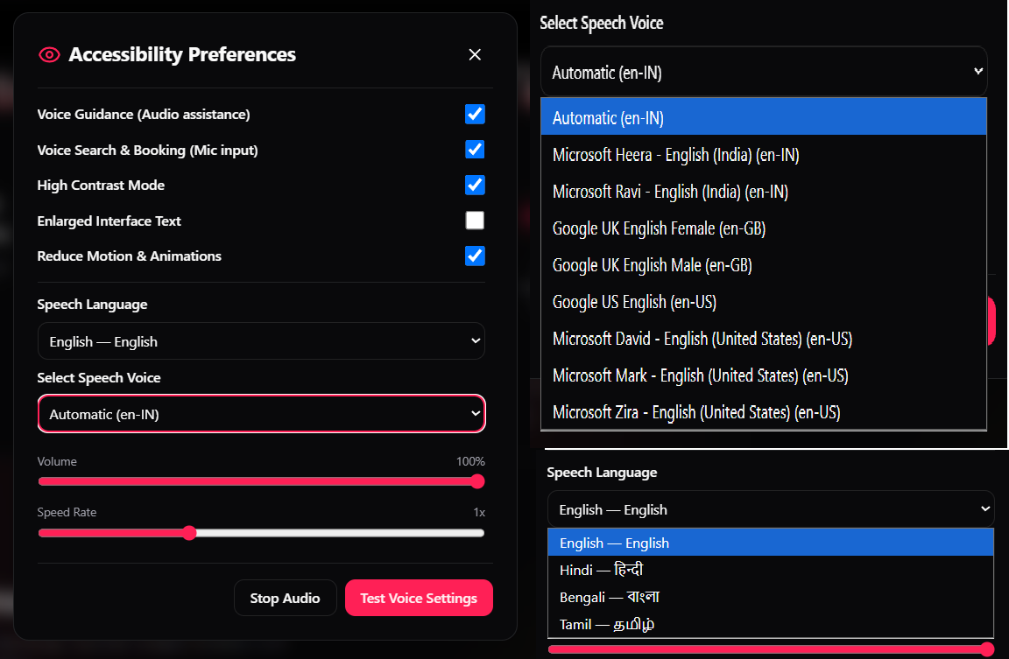

- Feedback system enables visitors to share their experiences and suggestions, supporting continuous improvement of services and system performance
.
- Interactive Quiz for Kids is a fun learning feature that engages children with age-appropriate questions about museum exhibits, history, science, and culture.
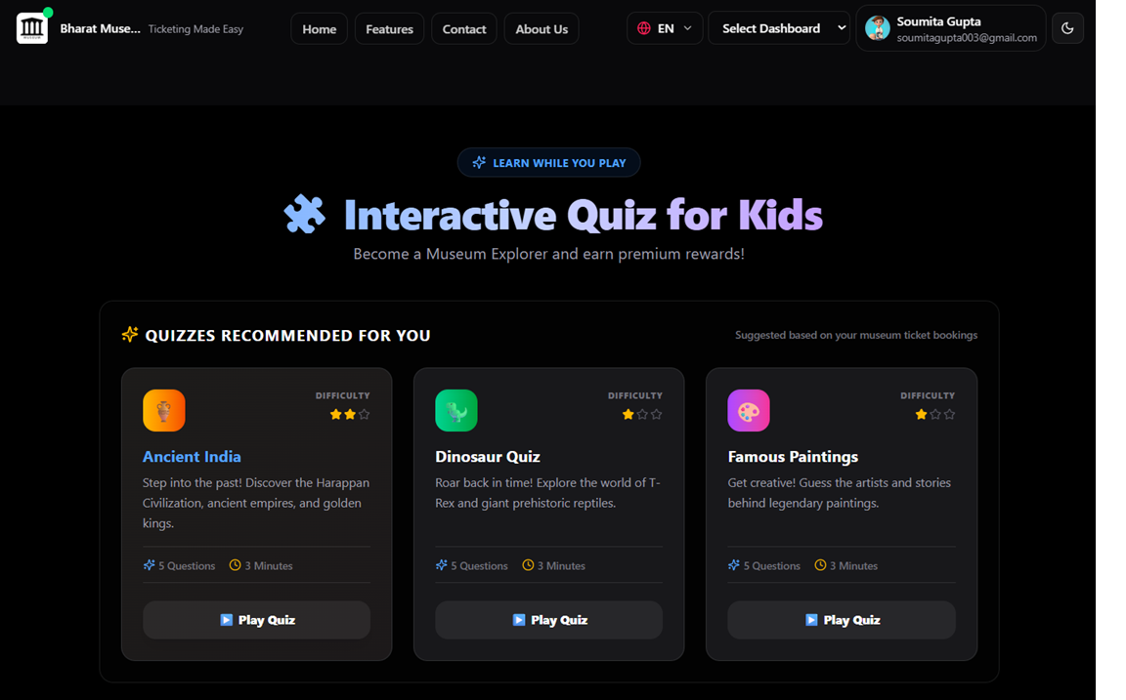
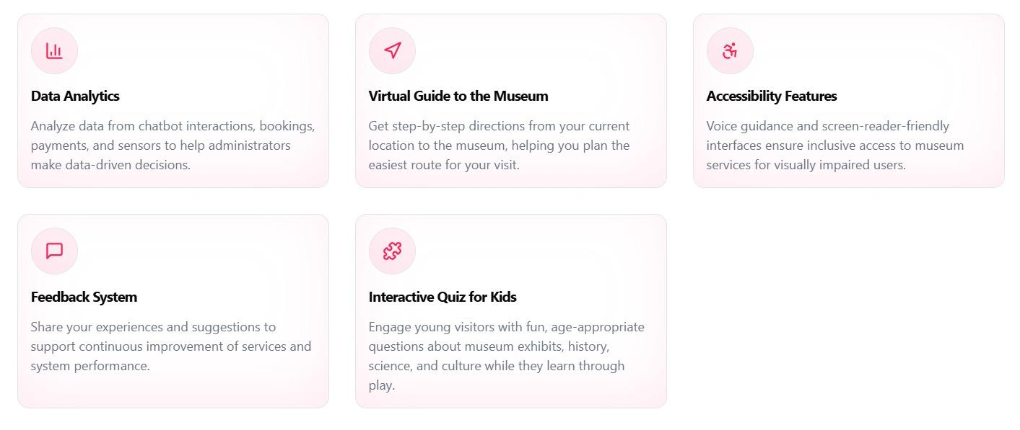
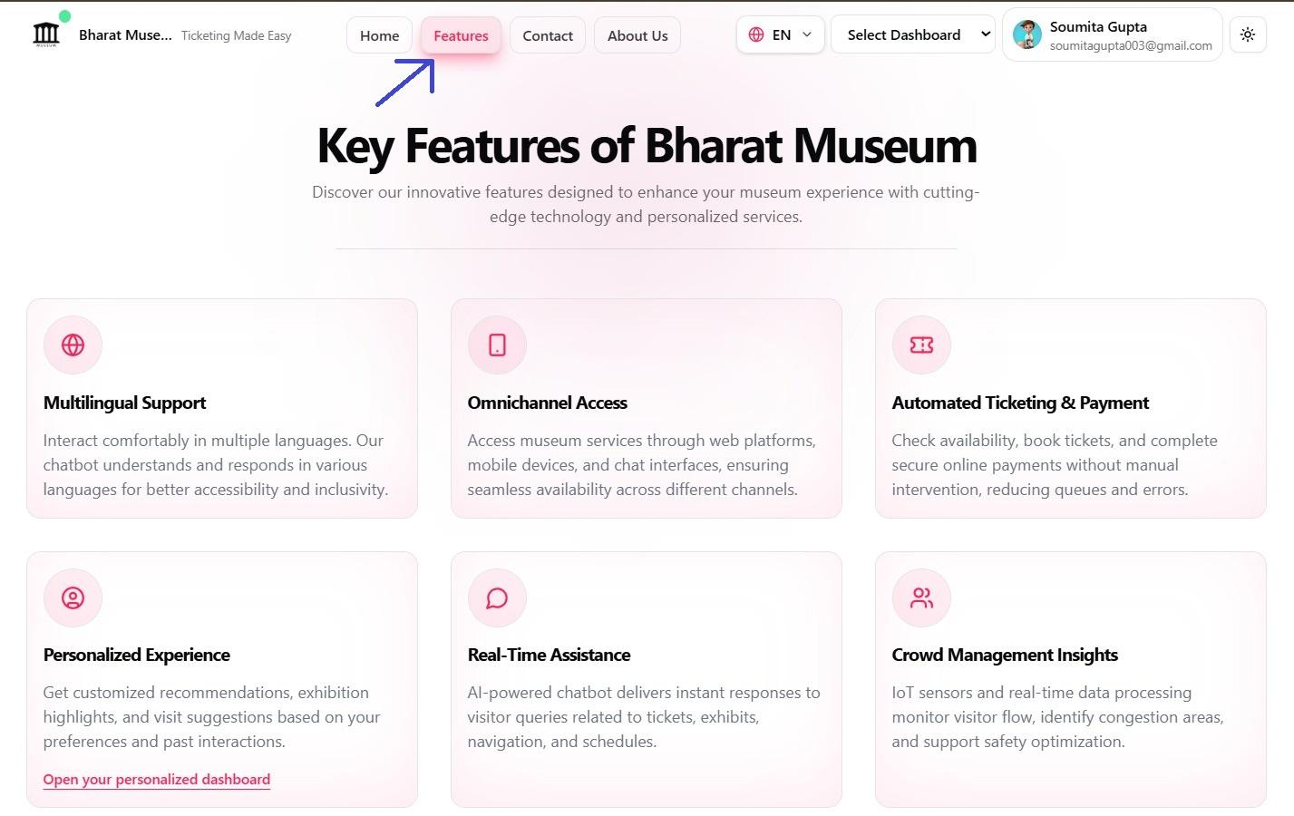

4. Motivation:
The motivation for developing an AI-enabled chatbot-based museum ticketing system originates from the limitations of traditional ticketing models and the growing expectations of digitally empowered visitors. The following points summarize the core motivations that guided the design and implementation of this system.
🔹 Multilingual Support
Museums attract visitors from diverse cultural and linguistic backgrounds. Existing systems often provide information only in one or two languages, creating communication barriers for international tourists. A multilingual chatbot allows users to interact in their preferred language, ensuring inclusivity and better understanding. This feature enhances accessibility, reduces confusion during booking, and improves overall visitor satisfaction.
🔹 Omnichannel Access (Web, Mobile, Chat)
Modern users expect flexibility in how they access services. This system motivates the integration of omnichannel access by enabling visitors to book tickets through websites, mobile applications, and chatbot interfaces. Whether a user interacts via desktop, smartphone, or messaging platforms, the experience remains seamless and consistent. Omnichannel access increases reach, convenience, and engagement.
🔹 Automated Ticketing & Payment Processing
Manual ticketing methods are time-consuming and prone to errors. Automation ensures smooth ticket booking, secure online payments, instant confirmations, and digital ticket delivery. This motivation focuses on reducing queues, eliminating manual intervention, increasing transaction accuracy, and providing faster service to visitors.
🔹 Personalized Visitor Experience
Every visitor has unique interests and preferences. The motivation behind personalization is to use AI-driven insights to recommend exhibitions, guided tours, preferred visiting times, and special events. Personalized interactions enhance user engagement, encourage repeat visits, and create a tailored museum experience.
🔹 Real-Time Assistance
Visitors frequently need instant information regarding ticket availability, prices, timings, or special discounts. A chatbot provides real-time assistance without human involvement. This motivation improves responsiveness, reduces dependency on staff, and ensures 24/7 support for user queries.

🔹 Crowd Management Insights
During peak seasons and special exhibitions, overcrowding becomes a major issue. The motivation lies in using real-time booking and visitor data to predict crowd density, manage time slots, and regulate visitor flow. This leads to improved safety, better comfort, and enhanced operational efficiency.
🔹 Data Analytics for Operational Improvements
The system collects valuable visitor data such as booking patterns, peak hours, visitor demographics, and popular exhibits. This motivation supports data-driven decision-making for staff allocation, pricing strategies, exhibition planning, and marketing campaigns.
🔹 Need for 24/7 Automated Booking
Most physical ticket counters function during limited working hours. This motivates the adoption of a chatbot-based system that operates 24/7, allowing tourists and visitors to book tickets at their convenience, regardless of time zones or physical availability.
🔹 Scalability & High-Volume Handling
During weekends, holidays, and events, traditional systems struggle to manage large crowds. The motivation includes:
- Minimizing waiting times
- Reducing staff workload
- Improving visitor flow management
- Automated systems ensure scalable handling of thousands of requests simultaneously.
🔹 Accessibility for Specially-Abled Visitors
The project is motivated by the need to create an inclusive environment. Features for visually impaired users include:
- Audio-based responses
- Voice-guided navigation
- Simplified chatbot conversations
- These features empower specially-abled visitors to access museum services independently.
🔹 Reducing Human Error & Increasing Automation
Manual operations often lead to errors in ticket allocation, payment handling, and record maintenance. Automation increases accuracy, reliability, and consistency across all ticketing and visitor management processes.

🔹 Environmental Motivation (Paperless System)
The motivation also stems from environmental responsibility. Digital ticketing promotes:
- Eco-friendly paperless transactions
- Reduced carbon footprint
- Lower paper consumption and waste
🔹 Enhanced Visitor Experience & Engagement
Beyond ticketing, the system motivates user engagement through:
- Virtual tours
- Personalized content recommendations
- Quizzes and interactive learning modules
- Social media sharing features
- These elements transform the museum visit into an immersive and educational journey.

5. Objectives:
The primary objectives of the proposed Online Chatbot-Based Ticketing System focus on transforming traditional museum ticketing and visitor management into an intelligent, automated, and user-centric digital platform. Each objective addresses a specific operational and experiential requirement of modern museums.
Objective A: Develop an AI-Powered Multilingual Chatbot
The first objective is to design and implement an AI-driven chatbot capable of interacting with visitors in multiple languages. This chatbot will serve as the primary communication interface, assisting users with inquiries related to museum details, ticket pricing, schedules, and services. Multilingual support ensures inclusivity for international visitors and reduces communication barriers. The chatbot will provide real-time responses, guide users through the booking process, and deliver consistent information without human intervention.

Objective B: Implement a Fully Automated Ticketing & Payment System
This objective aims to automate the entire ticket booking workflow based on the system’s DFD flow. The process includes user login or signup, museum search, ticket booking request submission, real-time availability verification, secure online payment, and automatic ticket generation. Automation minimizes manual effort, reduces booking errors, and ensures instant confirmation through digital tickets, improving efficiency for both visitors and museum administrators.
Objective C: Enhance Visitor Experience Through Smart Features
To make museum visits more engaging, the system integrates smart features such as virtual guides and virtual video-based museum tours. Personalized recommendations based on visitor preferences enhance satisfaction and engagement. Additionally, accessibility options—especially for visually impaired visitors—such as voice guidance and audio responses, promote inclusivity and independent access.

Objective D: Provide Real-Time Crowd Management & Analytics
This objective focuses on collecting and analyzing visitor data to monitor crowd density and peak visiting hours. Real-time analytics help museums manage visitor flow, improve safety, and optimize staffing and scheduling decisions.

Objective E: Ensure Strong Security, Reliability, and System Integration
The system emphasizes secure transactions, reliable cloud hosting infrastructure, seamless integration with existing museum databases, and error-free automated workflows to ensure system stability, data protection, and uninterrupted service.

Objective F: Reduce Operational Costs and Environmental Impact
By minimizing manual labor, paper-based ticketing, and energy usage, the system aims to lower operational costs while promoting eco-friendly, paperless operations.

6. Technology Required:

A. Chatbot Engine: ChatterBot (Python)
Purpose
- Provides AI-driven conversational responses.
- Handles basic dialog flow and reply generation.
How it works
- Uses a database of conversations to learn patterns.
- Matches user input with similar past conversations.
- Generates appropriate responses based on confidence scoring.
Role in the system
- Acts as the core conversational brain.
- Handles FAQs like:
  - Museum timings
  - Ticket prices
  - Location details
  - Rules and guidelines
Integration
- Runs as a Python service.
- Exposed as an API.
- Node.js backend sends user messages to ChatterBot and receives replies.

B. NLP Framework: spaCy
Purpose
- Advanced Natural Language Processing.
- Enhances chatbot intelligence.
Functions
- Text preprocessing
- Tokenization
- Lemmatization
- Named Entity Recognition (NER)
- Intent detection
Role in the system
- Pre-processes user input before sending to ChatterBot.
- Helps route requests correctly:
  - Booking
  - Payments
  - Queries
  - Admin tasks

C. Backend Technology: Next.js Server & Node.js Runtime
Purpose:
Acts as the central processing and coordination layer of the system.
Responsibilities:
- Handling API requests and responses.
- Managing user authentication and authorization through Firebase Admin SDK.
- Executing business logic for ticket booking, payments, and chatbot operations.
- Facilitating communication between the frontend, chatbot engine, machine learning modules, database, and IoT hardware devices.
- Processing and managing real-time sensor data and user interactions.
- Ensuring secure and efficient data exchange across all system components.

Key APIs
- /chat → chatbot conversation
- /book-ticket → booking logic
- /payment → payment gateway
- /sensor-data → IoT updates
- /admin → museum admin panel

Why Next.js?
- Provides both frontend and backend capabilities within a single framework.
- Supports Server-Side Rendering (SSR) and Static Site Generation (SSG) for improved performance.
- Ideal for real-time web applications such as chatbot-based museum systems.
- Seamlessly integrates with Firebase Authentication, Firestore Database, payment gateways, and external APIs.
- Offers optimized routing, API handling, and scalability for modern web applications.

D. Database Layer

a. Firestore Database (FSDB)
Used for
- Chat history
- Analytics
- Conversation logs
- User interaction patterns
Why Firestore Database (FSDB) ?
- Schema-less
- Good for dynamic chatbot conversations
- Fast querying for analytics

b. Firebase
Used for
- User authentication
- Real-time updates
- Booking data
- Notifications
- Cloud storage
Firebase services
- Firebase Auth → login/signup
- Firestore → bookings, users, tickets
- Firebase Storage → QR codes, images
- Cloud Messaging → alerts & notifications

Why Firebase ?
- Real-time sync
- Secure
- Scales easily
- Perfect for frontend + backend integration

E. Cloud Hosting

a. Vercel
- Frontend + Backend Deployment
- Fast global CDN
- Easy deployment for Next.Js Fullstack apps

b. Render
- Hosts:
  - Python chatbot & NLP services
- Auto-scaling
- Easy CI/CD from GitHub

F. Frontend: Next.JS
Purpose
- User interaction layer.
Interfaces
- Visitor website
- Chatbot UI
- Ticket booking portal
- Museum admin dashboard
- Controller Dashboard
Features
- Real-time chatbot chat window
- QR-based ticket display
- Booking history
- Admin analytics panel
Why NextJs?
- Fast rendering
- Component-based
- Works well with Firebase & REST APIs

G. Additional Technical Elements

API Integration
- Ticket availability APIs
- Museum event schedules
- External tourism data

Payment Gateway
- Razorpay
- Secure transactions
- Payment confirmation triggers ticket generation

Real-Time Database Updates
- Booking confirmation
- Visitor count updates
- Sensor-triggered alerts

Authentication Services
- Firebase Auth

- Role-based access:
  - Admin
  - Museum
  - Controller
  - User

H. IoT & Hardware Integration

a. ESP32 DevKit V1 (Main Controller)
Role
- Central hardware controller
- WiFi-enabled
- Sends sensor data to backend
Connected to
- Ultrasonic sensor HC-SR04× 2
- IR sensor x 1
- RFID reader MFRC522 × 2
- Servo motor SG90 × 3
- SSD1306 OLED x 1
- Buzzer

b. HC-SR04 Ultrasonic Sensor
Purpose
- Visitor counting
- Distance measurement
Use case
- Detects entry/exit
- Updates live visitor count to Firebase

c. IR Sensor
Purpose
- Detects close-range presence
Use case
- Trigger welcome messages
- Activate displays
- Control entry gates

d. RFID RC522 Module
Purpose
- Ticket validation
Use case
- Scan RFID card or wristband
- Verify ticket authenticity
- Allow entry if valid

e. Servo Motor SG90
Purpose
- Physical movement
Use case
- Open/close entry gate
- Control mechanical barriers
- Automated access control

7. Methodology:

A. System Overview:
The proposed system is an integrated AI-based smart museum management and visitor assistance platform that combines artificial intelligence, cloud computing, real-time databases, web technologies, and IoT hardware into a single unified solution. The primary goal of the system is to enhance visitor experience, automate museum operations, and provide real-time monitoring and control using intelligent software and connected hardware devices. The system is designed to operate seamlessly across frontend interfaces, backend services, AI processing modules, databases, cloud hosting platforms, and physical hardware components installed at the museum premises.

B. Frontend Layer (Next Js):
The frontend of the system is developed using Next.js, which provides a fast, scalable, and highly responsive user experience through server-side rendering and optimized page loading. Visitors access the system through a web application where they can register or log in using Firebase Authentication. Once authenticated, users can interact with the chatbot, explore museum information, check ticket availability, book tickets, and complete online payments. The chatbot interface is seamlessly integrated into the frontend, enabling users to communicate naturally through text-based conversations. Administrators access a dedicated dashboard that provides real-time insights into visitor statistics, ticket bookings, sensor data, and chatbot interactions. The Next.js frontend communicates securely with the backend through REST APIs hosted on cloud platforms, ensuring efficient, reliable, and secure data exchange across the system.

C. Backend Layer (Next.js Server and API Routes)
The backend of the system is implemented using Next.js server-side capabilities, which act as the central coordination layer for application operations. Next.js API Routes and Server Components handle incoming requests from the frontend, validate user authentication through Firebase Admin SDK, execute business logic, and communicate with external services such as the chatbot engine, NLP modules, databases, payment gateways, and IoT devices. The underlying Node.js runtime enables efficient handling of asynchronous operations and multiple concurrent requests, making the system suitable for real-time applications involving chatbot interactions and IoT data streams. The backend exposes secure API endpoints for chatbot communication, ticket booking, payment processing, sensor data management, and administrative functions. This architecture ensures seamless integration between frontend and backend components while maintaining modularity, scalability, and high performance.

D. AI & NLP Layer (Python):
The artificial intelligence layer of the system is developed using Python and consists of two major components: the ChatterBot engine and the spaCy NLP framework. ChatterBot serves as the conversational engine responsible for generating intelligent responses to user queries. It is trained using museum-specific datasets that include frequently asked questions, ticketing information, museum rules, exhibition details, and visitor guidelines. When a user sends a message, the backend forwards the message to the AI service, where ChatterBot analyzes the input and generates an appropriate response based on similarity matching and confidence scoring. This enables the chatbot to provide natural and context-aware replies to visitors at any time.

E. Chatbot Engine: ChatterBot and NLP Framework: spaCy:
Before the message is processed by ChatterBot, spaCy is used to perform advanced natural language processing. spaCy analyzes the user input by performing tokenization, lemmatization, and stop-word removal, and then identifies user intent and extracts relevant entities such as dates, number of tickets, museum names, and event types. This structured information allows the system to distinguish between different types of user requests, such as general inquiries, ticket booking requests, or payment-related queries. By combining spaCy with ChatterBot, the system achieves higher accuracy and better understanding of user intent, which significantly improves the overall conversational experience.

F. Database Layer:
The database layer of the system is implemented using Firebase Firestore, a cloud-based NoSQL database that provides scalable, secure, and real-time data storage. Firestore stores all application data, including user profiles, ticket bookings, chatbot interactions, museum information, sensor records, payment details, and administrative data. Firebase Authentication is integrated with Firestore to manage secure user login, registration, and role-based access control.
Firestore's real-time synchronization capabilities enable instant updates across the frontend, backend, chatbot system, and administrator dashboard. This ensures that users and administrators always have access to the latest information without requiring manual page refreshes. The database architecture supports efficient data retrieval, high availability, and seamless scalability, making it suitable for handling both user interactions and real-time IoT data within the museum management system.

G. Payment Gateway Integration:
The system integrates a secure online payment gateway to enable visitors to purchase tickets digitally. When a user initiates a ticket booking, the frontend sends the request to the backend, which calculates pricing and forwards the payment request to the payment gateway. Once the payment is successfully completed, the backend verifies the transaction and generates a digital ticket. The ticket information is stored in Firebase, and a confirmation is sent to the user. This process ensures a smooth and secure booking experience without the need for manual intervention.

H. Cloud Hosting Layer:
Cloud hosting plays a critical role in ensuring system availability, scalability, and reliability. The Node.js backend and Python-based AI services are hosted on Render, which provides automatic deployment, scaling, and monitoring. Vercel is used to host the fullstack application, offering fast global content delivery and seamless integration with Firebase services. This cloud-based architecture allows the system to handle varying traffic loads and ensures that the chatbot and booking services remain available at all times.

I. IoT & Hardware Layer:

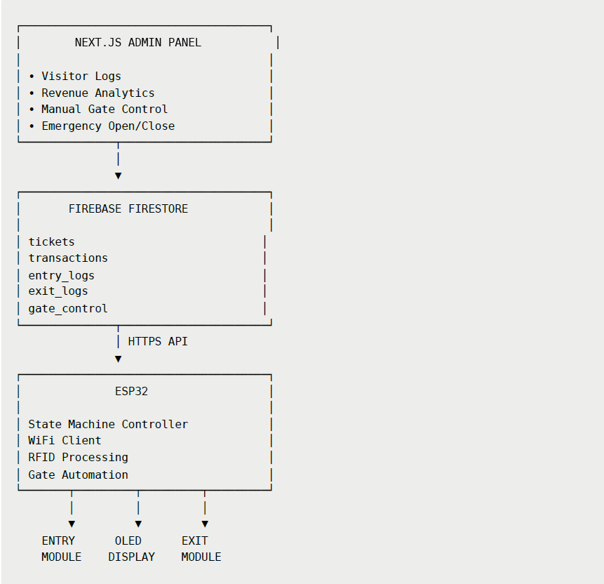
a. Complete system architecture

b. Entry gate architecture

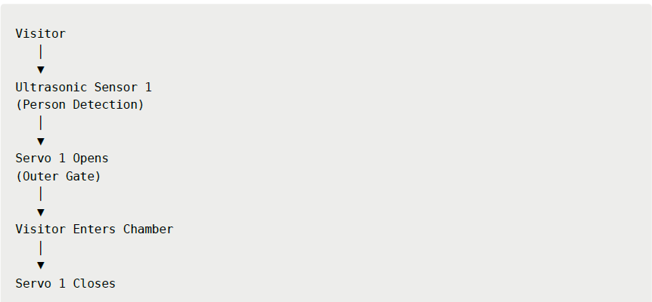

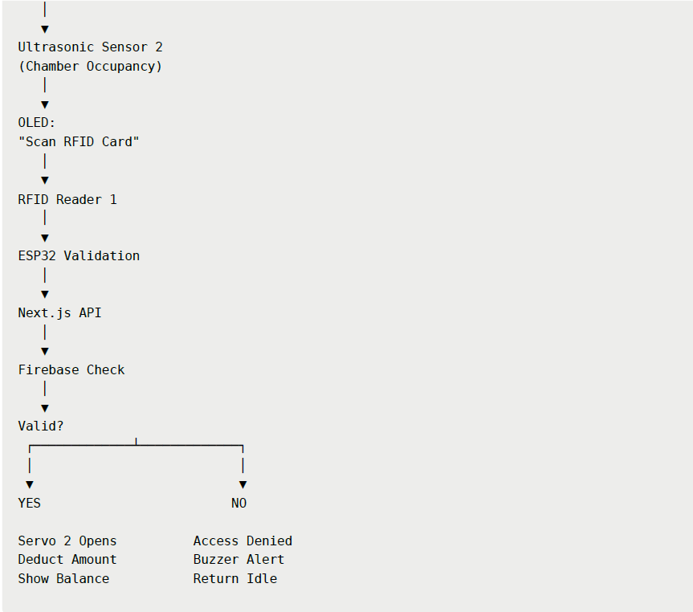
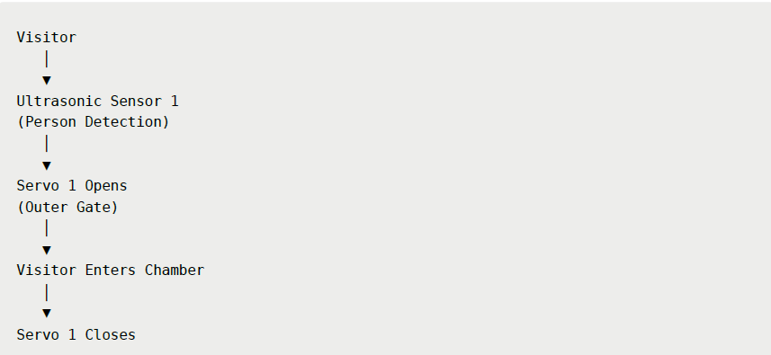
c. Exit gate architecture

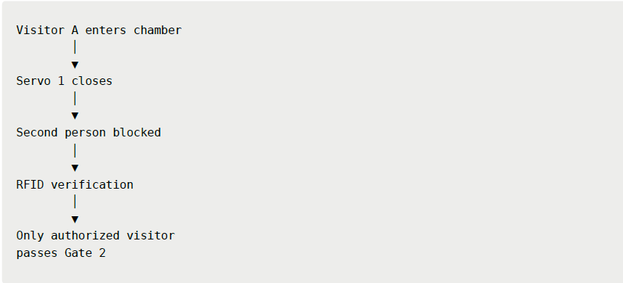
d. Anti-tailgating security logic

Benefits

- Prevents multiple people entering on one ticket
- Simulates commercial access-control systems

OLED display workflow

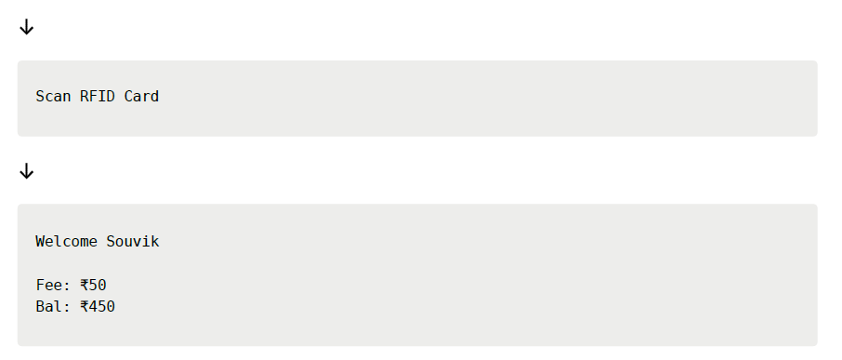
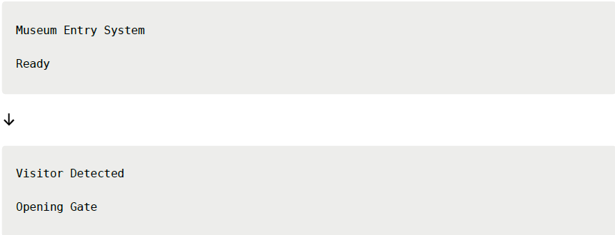

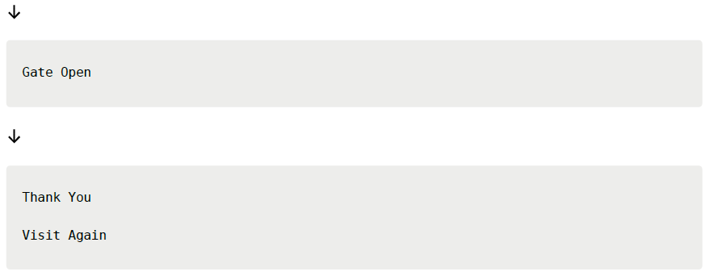

Manual gate control (dashboard controls)
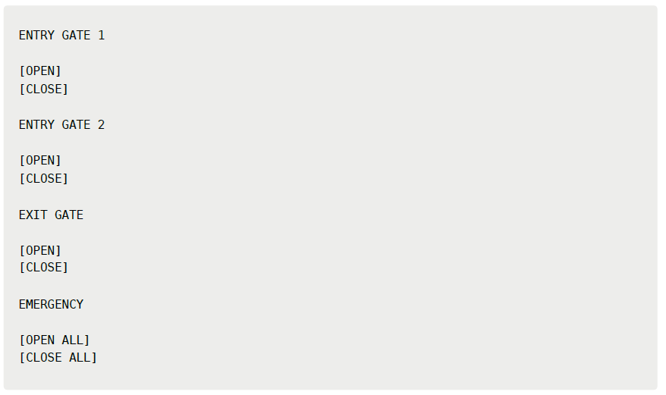

Workflow
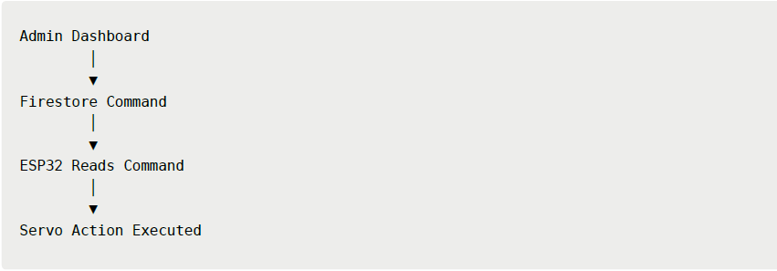

g. Visitor transaction flow
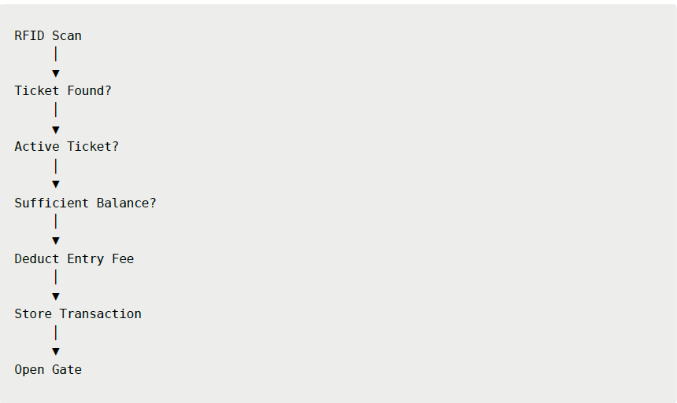

h.Firestore collections
Tickets

"active": true
}

{
"uid": "RF12345",
"name": "Visitor Name", "balance": 500,

Transactions

{
"uid": "RF12345",
"amount": 50,
"balanceAfter": 450, "timestamp": "..."
}
entry_logs

{
"uid": "RF12345",
"entryTime": "..."
}

exit_logs

{
"uid": "RF12345",
"exitTime": "..."
}
gate_control

{
"servo1": "close",
"servo2": "close",
"servo3": "close"
}

i.System State Machine
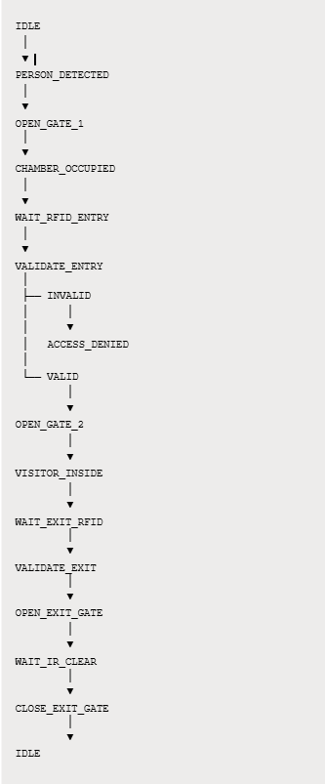

j. ESP32 Microcontroller and HC-SR04 Ultrasonic Sensor:
The IoT and hardware layer of the system enables physical access control and real-time visitor monitoring within the museum. The ESP32 microcontroller serves as the central hardware controller and is responsible for connecting sensors, RFID modules, and actuators to the cloud backend. The ESP32 communicates with the backend server over WiFi, sending sensor data and receiving control commands in real time. The HC-SR04 ultrasonic sensor is used to measure distance and count visitors as they enter or exit the museum. This data is transmitted to the backend, which updates the visitor count in Firebase, allowing administrators to monitor crowd levels instantly.

k. IR Proximity Sensor and RFID RC522 Module:
The IR proximity sensor is used for short-range detection and helps trigger automated responses such as activating displays or initiating entry procedures when a visitor approaches. The RFID RC522 module is used for ticket validation and secure access control. Each visitor is issued an RFID card or tag linked to their booking information stored in Firebase. When the RFID is scanned at the entrance, the ESP32 sends the unique identifier to the backend server, which verifies the ticket’s validity. If the ticket is valid, the backend sends an approval signal to the ESP32, which then activates the SG90 servo motor to open the entry gate. After the visitor passes through, the gate automatically closes, ensuring controlled and secure access.
Throughout the operation of the system, all data generated by user interactions, payments, and hardware sensors is continuously logged and stored in the database. This data is visualized in the admin dashboard, allowing museum authorities to analyze visitor trends, peak hours, chatbot performance, and system usage. The integrated architecture ensures that the software and hardware components work together seamlessly, creating a smart, automated, and intelligent museum management system.

8. DFD ( Data Flow Diagram )

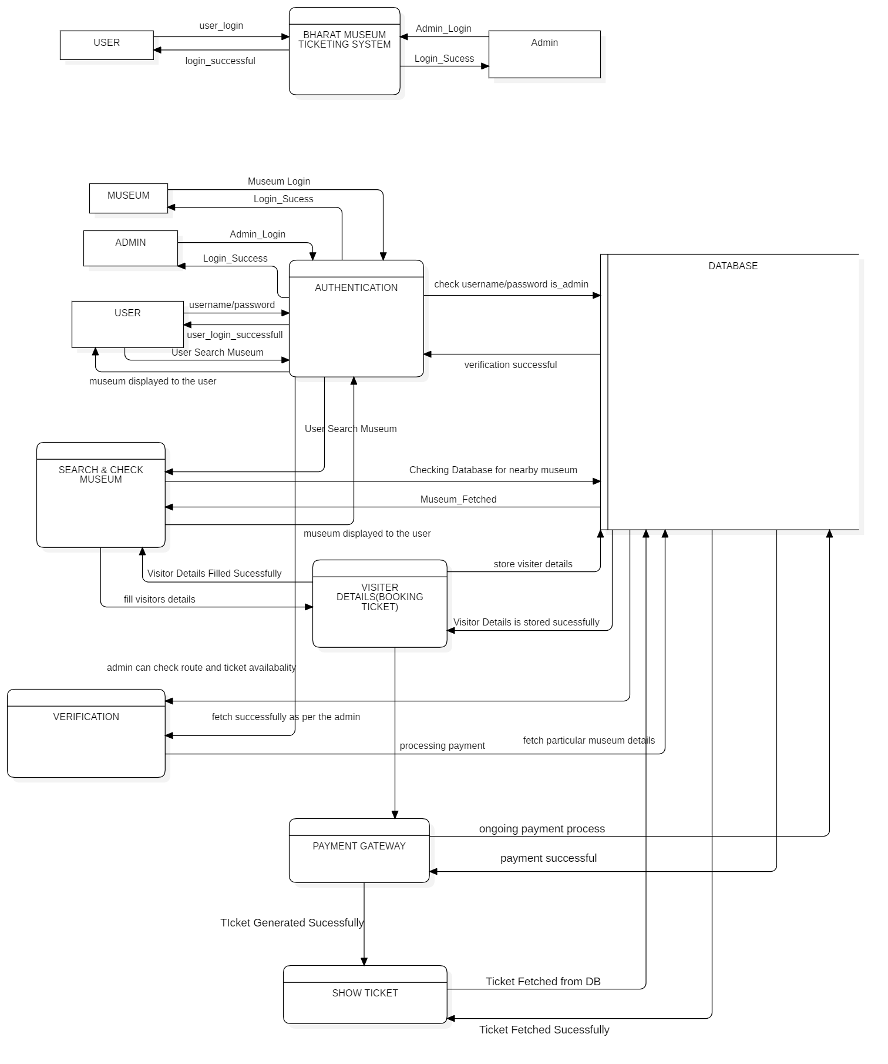

9. Sequence Diagram

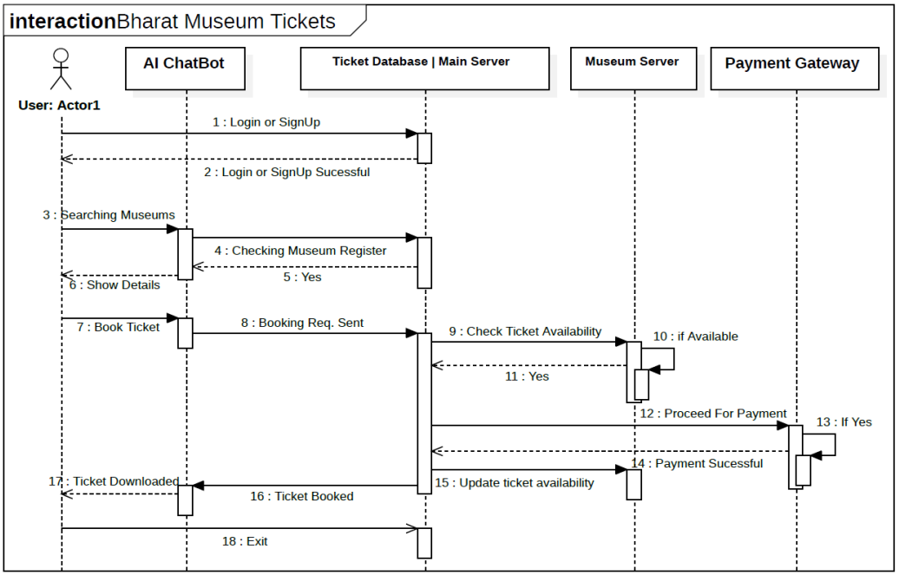

10. ER ( Entity Relationship ) Diagram

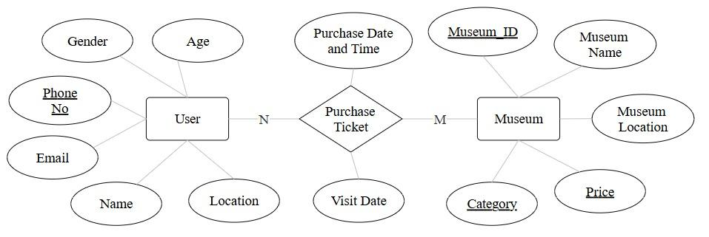

11. Analysis
The analysis of the proposed AI-based smart museum management and visitor assistance system shows that integrating conversational AI, cloud computing, real-time databases, and IoT hardware creates a highly efficient and scalable solution for modern museum operations. Traditional museum systems rely heavily on manual processes for ticketing, visitor guidance, and entry control, which often results in long queues, limited staff availability, and poor visitor engagement. The proposed system addresses these limitations by introducing automation at both the digital and physical levels.
From a technical perspective, the separation of concerns across different layers improves system reliability, scalability, and maintainability. The Next.js frontend provides a fast and responsive user experience, while its server-side capabilities handle API requests, authentication, and communication with external services. Firebase Authentication ensures secure user access and role-based authorization, while Firestore manages real-time data storage and synchronization across the application.
The modular architecture enables efficient handling of user interactions, ticket bookings, chatbot communication, payment processing, and IoT sensor data without compromising performance. By leveraging cloud-based services and real-time database capabilities, the system maintains high responsiveness and reliability while ensuring that users and administrators always have access to the most up-to-date information.
The use of Firebase services provides an efficient and unified platform for authentication, real-time data synchronization, and cloud database management. Firebase Authentication ensures secure user access and role-based authorization, while Firestore enables instant synchronization of bookings, chatbot interactions, visitor records, sensor data, and administrative information across the system. This real-time capability ensures that all users and administrators always have access to the most current data.
Cloud deployment through platforms such as Vercel, Firebase Hosting, and other cloud services ensures high availability, scalability, security, and simplified deployment workflows. These technologies enable the system to handle increasing user traffic efficiently while maintaining reliable performance and seamless user experiences.

The integration of IoT hardware, including ESP32, sensors, RFID modules, and servo motors, extends the system beyond software automation into physical access control and monitoring. This real-world integration increases system accuracy in visitor counting and enhances security through automated entry validation. Overall, the analysis indicates that the proposed system is technically feasible, scalable, secure, and well-suited for real-world deployment in smart museum environments.

12. Conclusion:
The conclusion of this project highlights the successful design and integration of an AI-driven smart museum management system that combines modern web technologies, artificial intelligence, cloud services, and IoT hardware into a unified and efficient solution. The system effectively addresses the limitations of traditional museum management methods by automating visitor interaction, ticket booking, access control, and real-time monitoring. By using a conversational chatbot powered by ChatterBot and enhanced with spaCy for natural language understanding, the system provides visitors with instant, accurate, and user-friendly assistance, significantly improving overall visitor experience.
The use of a Next.js full-stack architecture ensures a fast, responsive, scalable, and modular application design. Next.js provides both frontend and backend capabilities within a unified framework, enabling efficient handling of user requests, server-side processing, and API management. Cloud-based deployment through platforms such as Vercel and Firebase Hosting ensures high availability, secure data management, and seamless scalability, making the system suitable for museums of varying sizes.
Firebase Authentication enhances system security through secure user login and role-based access control, while Firestore provides reliable cloud-based data storage with real-time synchronization capabilities. This allows instant updates of bookings, visitor information, chatbot interactions, and administrative data across the system. Together, these technologies ensure efficient performance, secure data handling, and a smooth user experience for both visitors and museum administrators.

The integration of IoT hardware such as ESP32, RFID modules, ultrasonic sensors, IR sensors, and servo motors extends the system’s capabilities into the physical domain. Automated entry validation, visitor counting, and gate control reduce the need for manual supervision while improving accuracy and safety. This seamless interaction between software intelligence and hardware automation demonstrates the practicality of smart infrastructure in public spaces.

13. Future Work:
- IoT Integration and Implementation :The core focus of this phase of the project is the seamless integration and robust implementation of Internet of Things (IoT) technologies. This involves moving beyond theoretical concepts and establishing a functional, interconnected system that can gather, process, and act upon real-world data.

- Implementing the Internet of Things (IoT) hardware is vital for real-time museum access control, visitor monitoring, and data collection. This section outlines connecting physical components (sensors/actuators) to the cloud system.

- Expand multilingual capabilities by adding more regional and international languages and integrating voice-based interaction using speech-to-text and text-to-speech technologies.
- Extend omnichannel access to popular messaging and social media platforms to increase user engagement and accessibility.

- Enhance personalization using advanced machine learning models to provide predictive recommendations and customized tour paths.

- Improve crowd management through predictive analytics to forecast visitor flow and dynamically manage entry limits and visitor routing.

- Upgrade virtual guide functionality with augmented reality and immersive 3D experiences for richer and more interactive tours.

- Strengthen accessibility features by supporting additional assistive technologies to cater to users with diverse needs.

- Integrate sentiment analysis into the feedback system to automatically evaluate visitor satisfaction and identify improvement areas.

- Connect the system with smart city infrastructure to enable broader integration for traffic, safety, and public space management.

14. References

A. Digital Ticketing, QR-Based E-Tickets, and Mobile Booking Systems
- Zhang, Y., Liu, H., & Wang, J. (2021). Design and implementation of QR-code-based electronic ticketing systems. Harbin Engineering Journal, 42(6), 112–118.
- Li, X., Chen, Z., & Sun, Y. (2020). Mobile-first reservation and e-ticketing platforms for public venues. Journal of Engineering Applications, 15(3), 45–52.
- Russo, A., & Richards, G. (2022). Smart tourism and predictive analytics for visitor flow management. Tourism Management Perspectives, 41, 100937.

B. Predictive Analytics for Visitor Load and Staffing Optimization
- Fernández-Alcantud, A., López-Sánchez, J., & Yubero, T. (2021). Visitor flow prediction using historical booking and sensor data. Expert Systems with Applications, 178, 114978.
- Wang, S., & Xu, L. (2020). Forecasting crowd behavior in cultural heritage sites using machine learning. Future Generation Computer Systems, 108, 133–144.

C. Chatbots in Museums and Cultural Heritage Institutions
- Pérez-Sanagustín, M., et al. (2020). Conversational agents for museums: A systematic literature review. Paradigm, 24(2), 89–104.
- Damiano, R., Lombardo, V., & Pizzo, A. (2019). Chatbots and conversational interfaces for cultural heritage. Journal on Computing and Cultural Heritage, 12(4), 1–27.

D. Classification and Functions of Museum Chatbots
- Hien, H. T., Cuong, P. N., Nam, L. N., Nhung, H. L. T., & Tung, L. D. (2018). Intelligent assistants in museums: Informational, navigational, and educational chatbots. Proceedings of the International Conference on Intelligent Systems, 73–80.
- Følstad, A., & Brandtzæg, P. B. (2017). Chatbots and the new world of HCI. Interactions, 24(4), 38–42.

E. Integration of Chatbot Interfaces with Ticketing Systems
- Patel, R., Mehta, K., & Shah, V. (2022). Chatbot-based ticket booking system with QR-code generation. IRJMETS – International Research Journal of Modernization in Engineering Technology and Science, 4(5), 1345–1351.
- Singh, A., & Verma, S. (2021). Natural language interfaces for automated ticket reservation systems. Proceedings of IEEE ICACCS, 876–881.

F. Benefits of Chatbot-Driven E-Ticketing Systems
- EveryTicket Research Group. (2023). Digital ticketing systems: Reducing queues, fraud, and operational costs. EveryTicket Industry Report, 1–18.
- McLean, G., & Osei-Frimpong, K. (2019). Chatbots and service automation in customer experience. Journal of Business Research, 96, 193–203.

G. Challenges, UX Gaps, and Evaluation Issues
- Følstad, A., Nordheim, C. B., & Bjørkli, C. A. (2018). What makes users trust a chatbot for customer service? CHI Conference on Human Factors in Computing Systems, 1–12.
- Paradigm Research Collective. (2022). Usability evaluation gaps in conversational AI systems. Paradigm, 26(1), 55–70.

